|  |
| --- |
| User Manual  Leave & Attendance Approval(HR & Manager) |
| REFERENCE: GW/ERP/USER MANUAL |
|  |
| **Genweb2 Ltd.** |
| **31-Jul-17** |



|  |
| --- |
|  |

Contents

1. Leave Request Approval by Department Manager 3

1.1 Leave Summary 3

1.2 First Approval Leave Request by Department manager 3

2. Leave Request Approval by HR Manager 5

2.1 Leave Summary 5

2.2 Final Approval Leave Request by HR Manager 6

3. Leave Allocation Request Approval by Department Manager 7

3.1 First Approval Leave Allocation Request by Department Manager 7

4. Leave Allocation Request Approval by HR Manager 8

4.1 Final Approval Leave Allocation Request by HR Manager 8

5. Short Leave Request Approval by Department Manager 9

5.1 First Approval Short Leave Request by Department manager 9

6. Short Leave Request Approval by HR Manager 10

6.1 Final Approval Short Leave Request by HR Manager 10

7. Manual Attendance Request Approval 11

7.1 Pending Manual Attendance 11

7.2 Approval Manual Attendance Request by Department manager 12

8. Alter Rostering Request Approval 13

8.1 Approval Alter Rostering Request 13

9. OT Request Approval by Department Manager 14

9.1 Pending OT Request 14

9.2 Approval OT Request by Department manager 14

10. OT Request Approval by HR Manager 15

10.1 Pending OT Request 15

10.2 Approval OT Request by HR manager 16

# 1. Leave Request Approval by Department Manager

## 1.1 Leave Summary

Department manager can see all of employee leave Summary.

Using the menu **Leave ‣ My Leaves ‣ Leave Summary**.

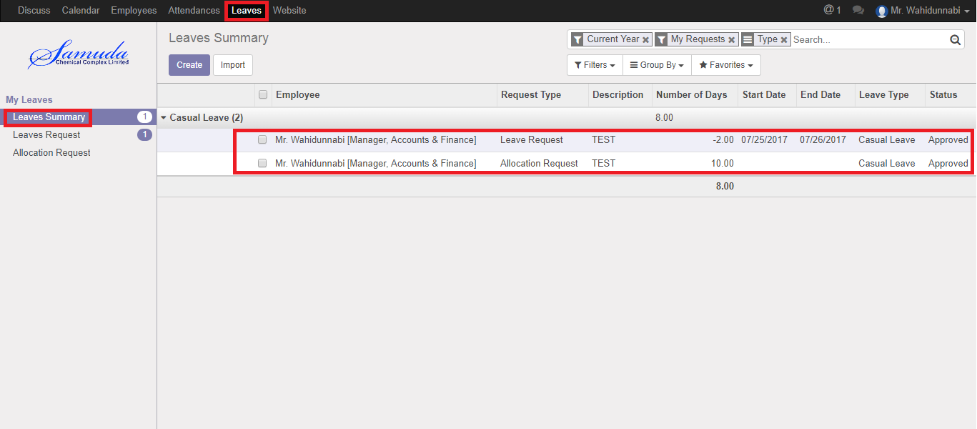

Figure: Leave Summary

## 1.2 First Approval Leave Request by Department manager

After apply the leave request “Department Manager” will get the notification. Department Manager can first approve the leave request. Department Management can update number of leave day(s) before approve. After Department Manager Approval, HR will get notification.

To see the employee leave request use the menu **Leave ‣ My Leaves ‣ Leaves Request.**

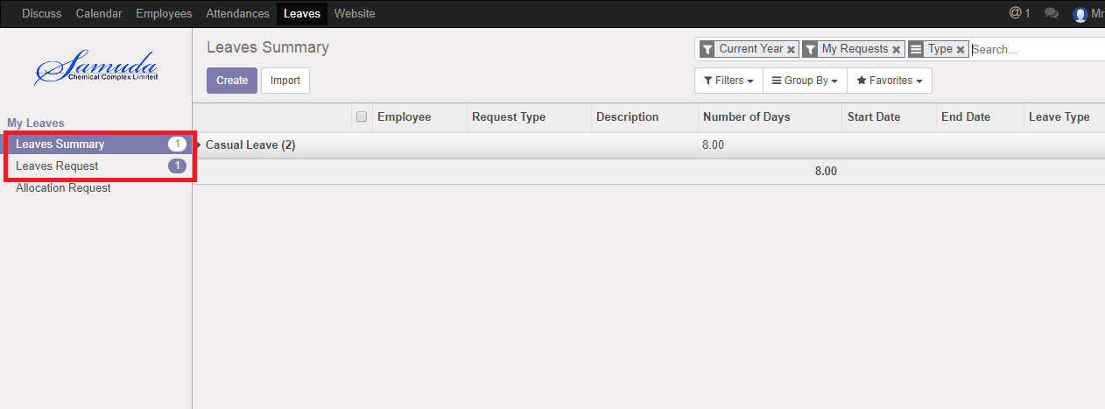

Figure: Leave Request Notification

Department manager can approve employee’s leave request. Department Manager can see all leave request there **Leave ‣ Leave to approve ‣ Leaves.**

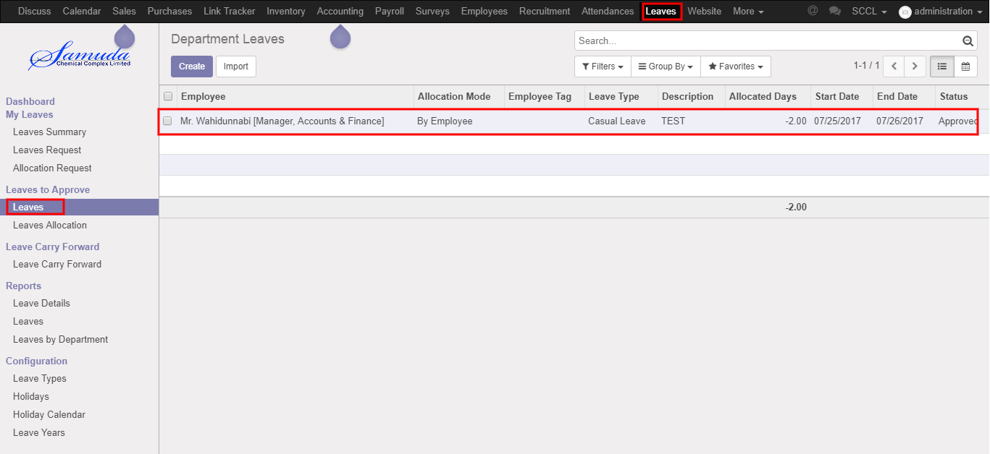

Figure: Leave Request List View

Here Department Manager can first approve the leave request by click on **Approve** button. He can update number of leave day(s) before approval.

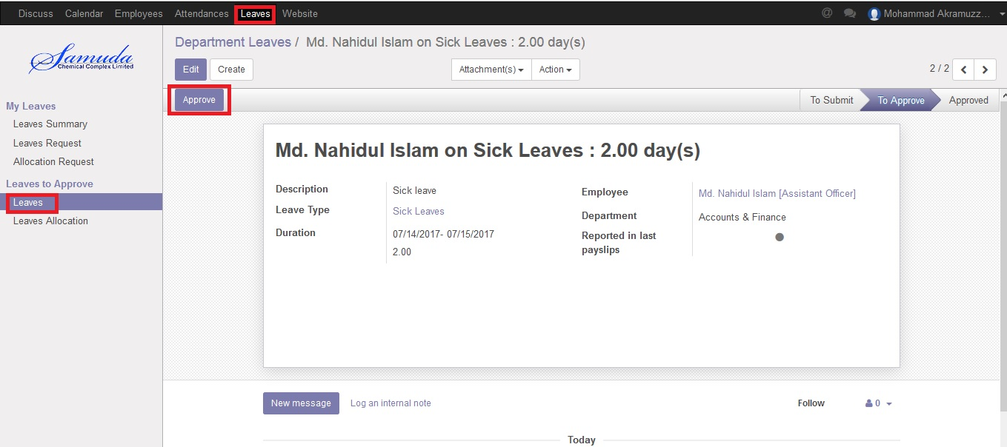

Figure: A Leave Request First Approval

Department Manager can refuse leave request by click **Refuse** Button.

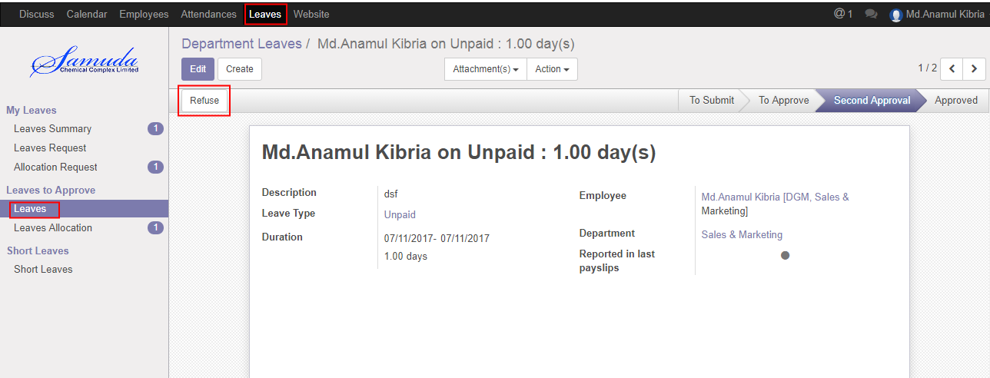

Figure: A Leave Request Refuse

# 2. Leave Request Approval by HR Manager

## 2.1 Leave Summary

HR Manager can see all of employee leave Summary.

Using the menu **Leave ‣ My Leaves ‣ Leave Summary**.



Figure: Leave Summary

## 2.2 Final Approval Leave Request by HR Manager

After Department manager’s first approval, HR manager can final approve or refuse the employee’s leave request. HRM can see all leave request there **Leave ‣ Leave to approve ‣ Leaves.**

Here HR Manager can final approve the leave request by click on **Validate** button.

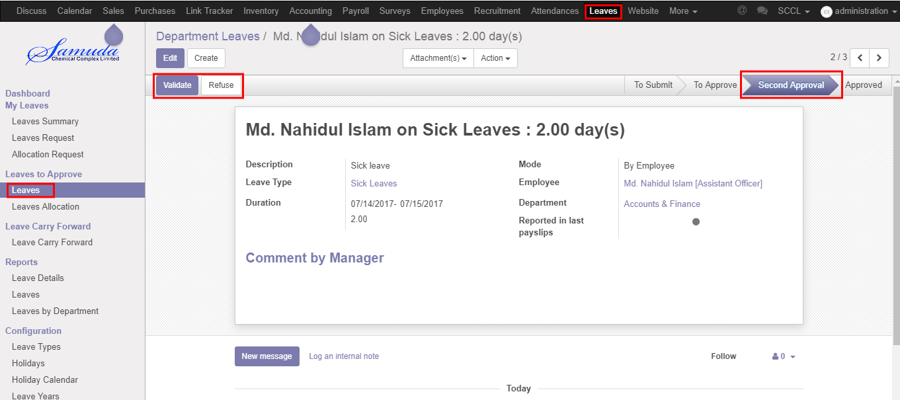

Figure: A Leave Request Second Approval

# 3. Leave Allocation Request Approval by Department Manager

## 3.1 First Approval Leave Allocation Request by Department Manager

After apply the leave allocation request “Department Manager” will get the notification. Department Management can update number of leave day(s) before approval. After Department Manager Approval, HR will get notification.

Here Department Manager can first approve the leave allocation request by click on **Approve** button.

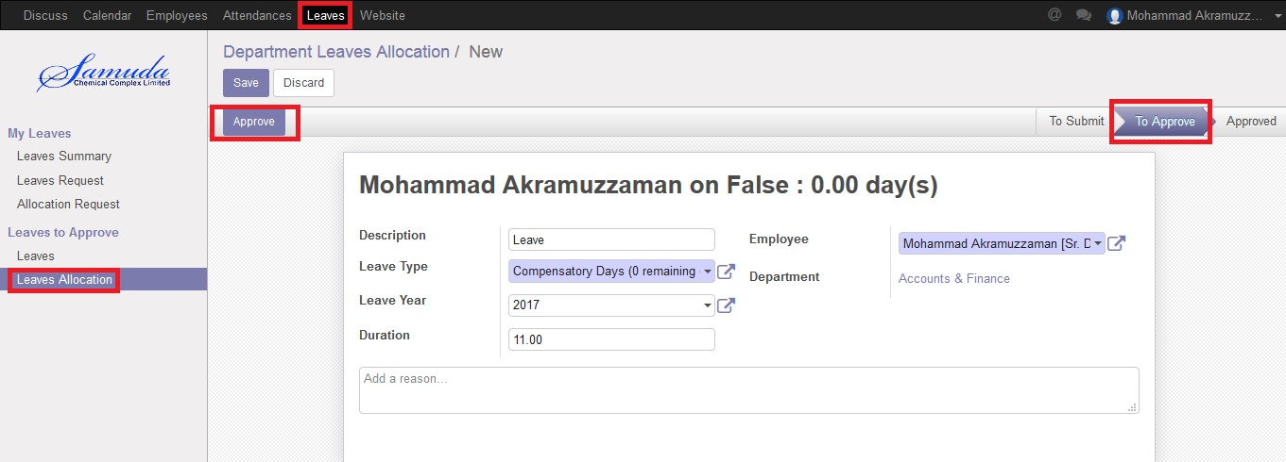

Figure: Leave Allocation Request First Approval

# 4. Leave Allocation Request Approval by HR Manager

## 4.1 Final Approval Leave Allocation Request by HR Manager

After apply the leave allocation request “HR Manager” will get the notification. After first approval the leave allocation request by Department Manager, HR Manager will get notification. HR Manager Can Approve or Refuse the leave allocation request. After that requested leave will finally approve.

Here HR Manager can final approve the leave request by click on **Validate** button.

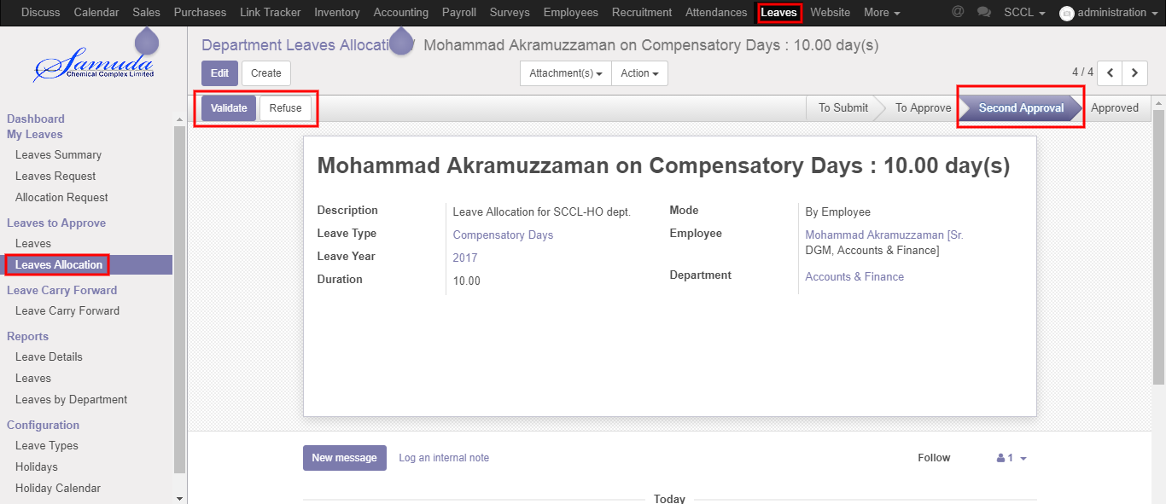

Figure: Leave Allocation Request Second Approval

# 5. Short Leave Request Approval by Department Manager

## 5.1 First Approval Short Leave Request by Department manager

After apply the Short leave request “Department Manager” will see the request. Department Manager can first approve the short leave request. After Department Manager Approval, HR will get notification. Department Manager can see all short leave request there **Leave ‣ Short Leaves ‣ Short Leaves.**

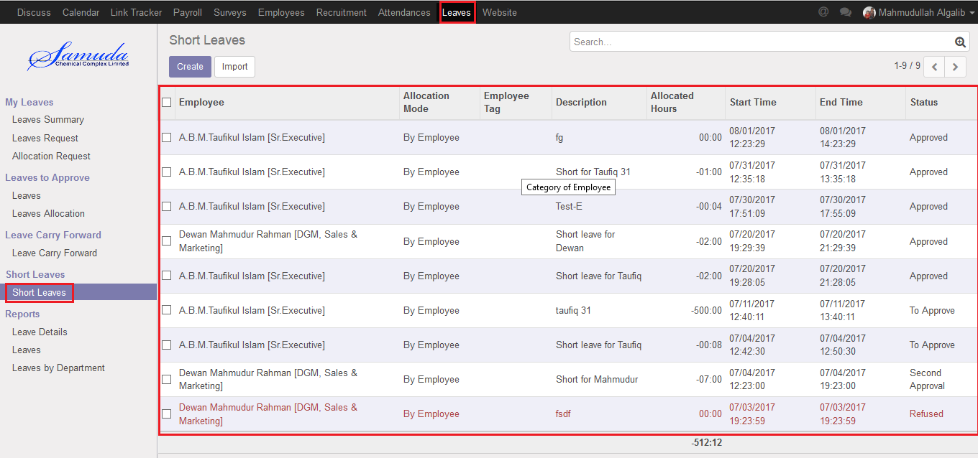

Figure: Short Leave Request List View

Here Department Manager can first approve the Short leave request by click on **Approve** button.

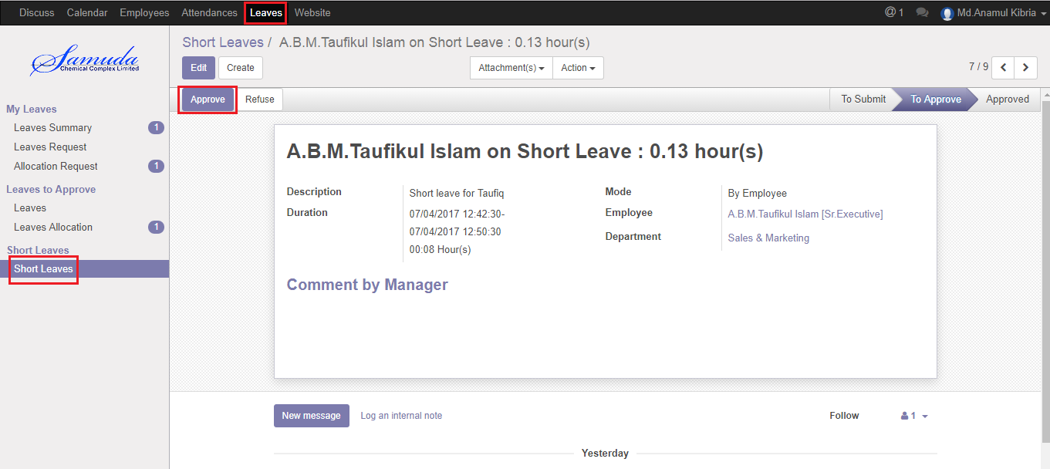

Figure: A Short Leave Request First Approval

Department Manager can refuse Short leave request by click **Refuse** Button.

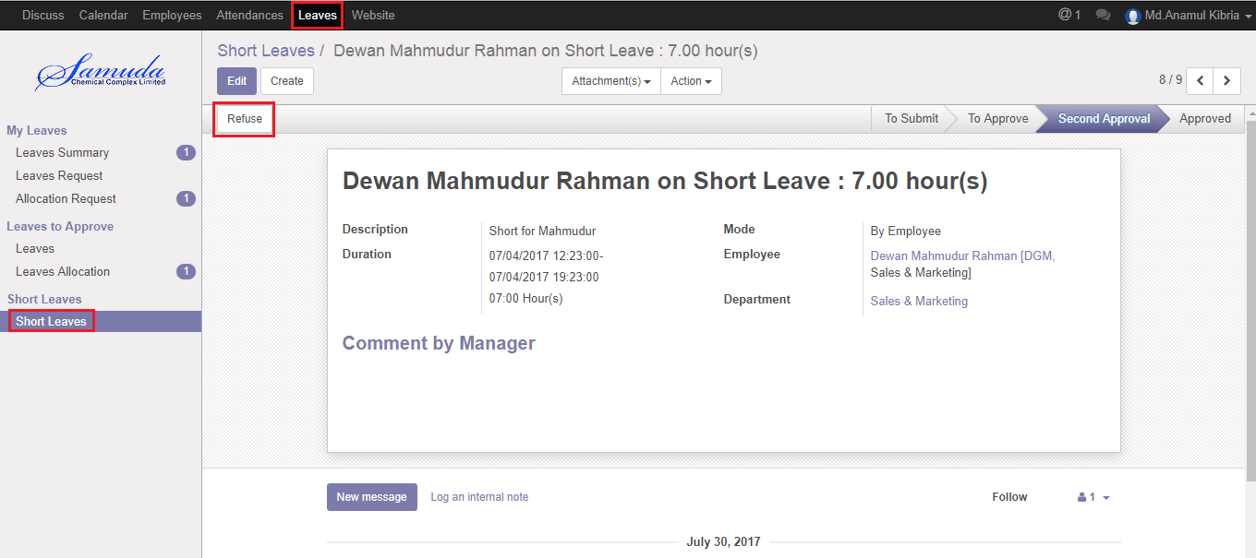

Figure: A Leave Request Refuse

# 6. Short Leave Request Approval by HR Manager

## 6.1 Final Approval Short Leave Request by HR Manager

After Department manager’s first approval, HR manager can final approve or refuse the employee’s Short leave request. HRM can see all short leave request there **Leave ‣ Short Leaves ‣ Short Leaves.**

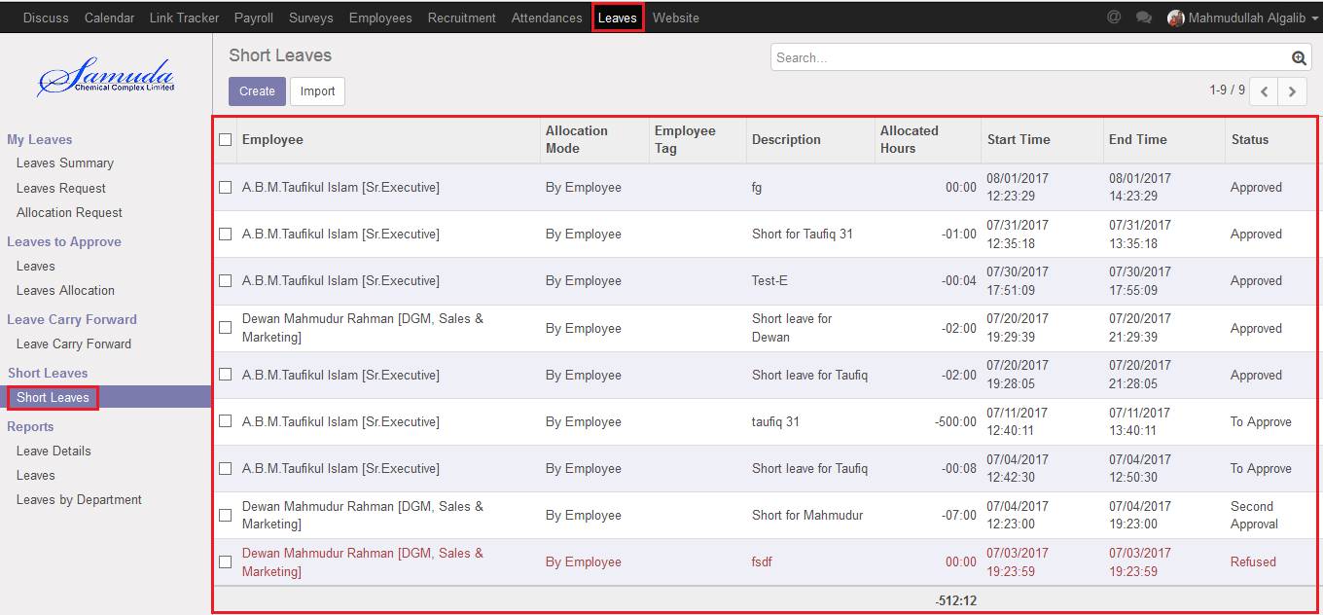

Figure: Short Leave Request List View

Here HR Manager can final approve the short leave request by click on **Validate** button and refuse the short leave request by click on **Refuse** button.

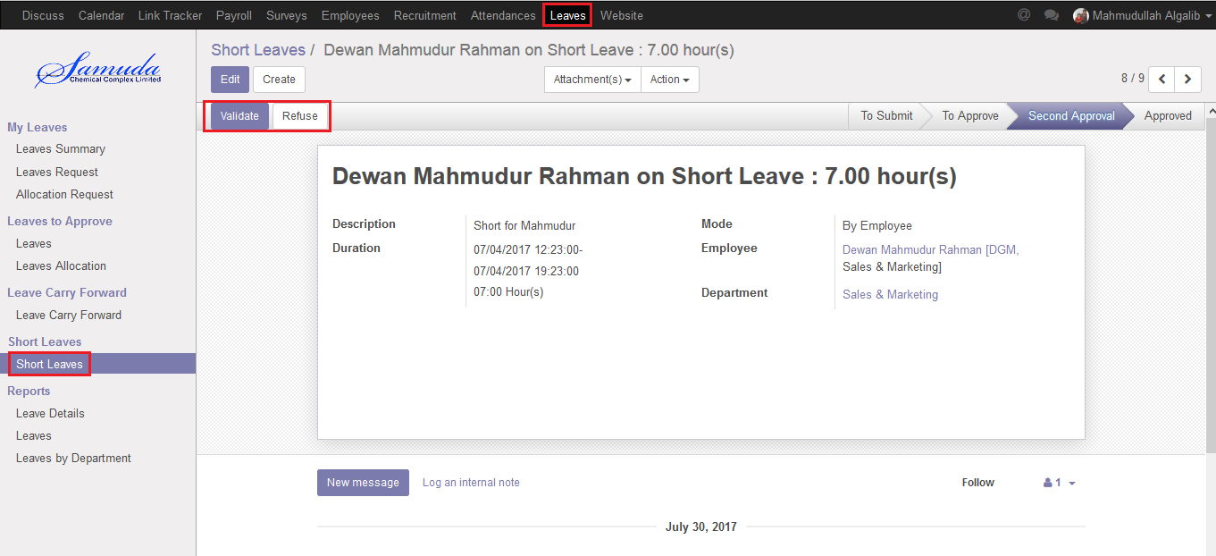

Figure: A Leave Request Second Approval

# 7. Manual Attendance Request Approval

## 7.1 Pending Manual Attendance

Department manager and HR Manager can see all of employee pending manual attendance request.

Using the menu **Attendance ‣ Pending Approvals**.

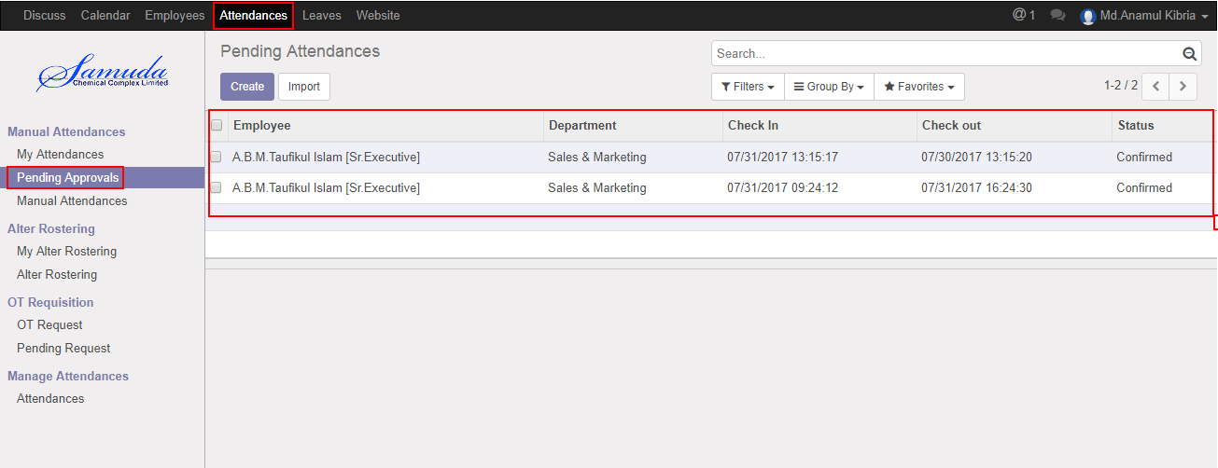

Figure: Manual Attendance Pending Approval List View

## 7.2 Approval Manual Attendance Request by Department manager

After apply the manual attendance request Department Manager and HR Manager will get the notification. Department Manager or HR Manager can approve the manual attendance request.

To see the employee manual attendance request use the menu **Attendance ‣ Pending Approvals**. Here Department Manager or HR Manager can approve the manual attendance request by click on **Approve** button.

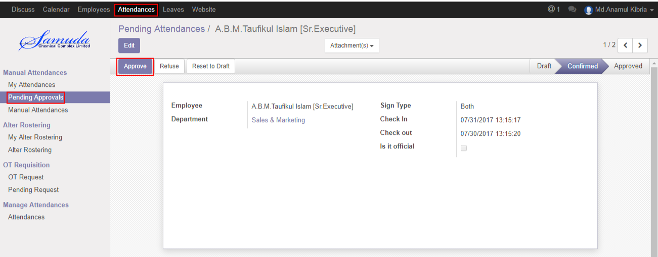

Figure: Manual Attendance Request Approval

Department Manager or HR Manager can refuse manual attendance request by click **Refuse** Button.

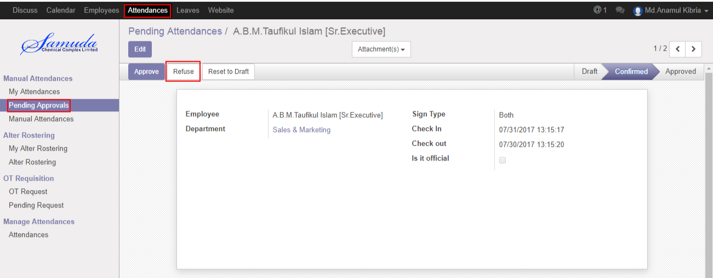

Figure: A Manual Attendance Request Refuse

# 8. Alter Rostering Request Approval

## 8.1 Approval Alter Rostering Request

After apply the alter rostering request Department Manager and HR Manager will get the notification. Department Manager or HR Manager can approve the alter rostering request.

To see the employee alter rostering request use the menu **Attendance ‣ Pending Approvals**. Here Department Manager or HR Manager can approve the alter rostering request by click on **Approve** button.

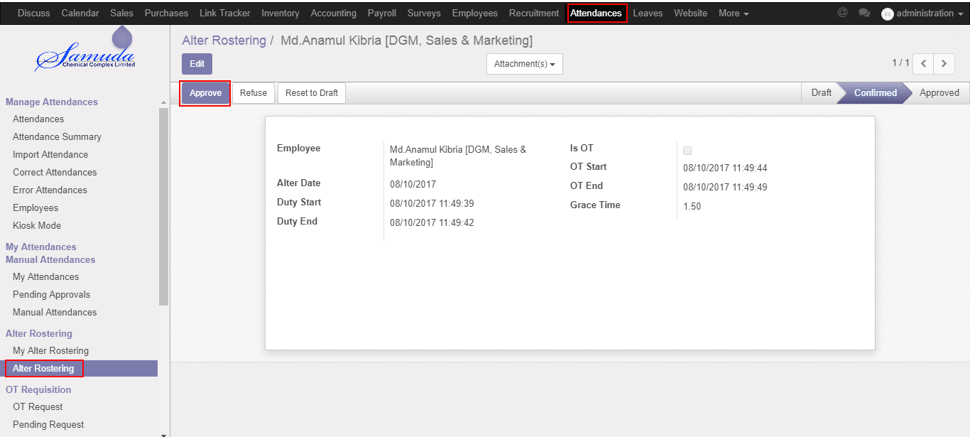

Figure: An Alter Rostering Request Approval

Department Manager or HR Manager can refuse alter rostering request by click **Refuse** Button.

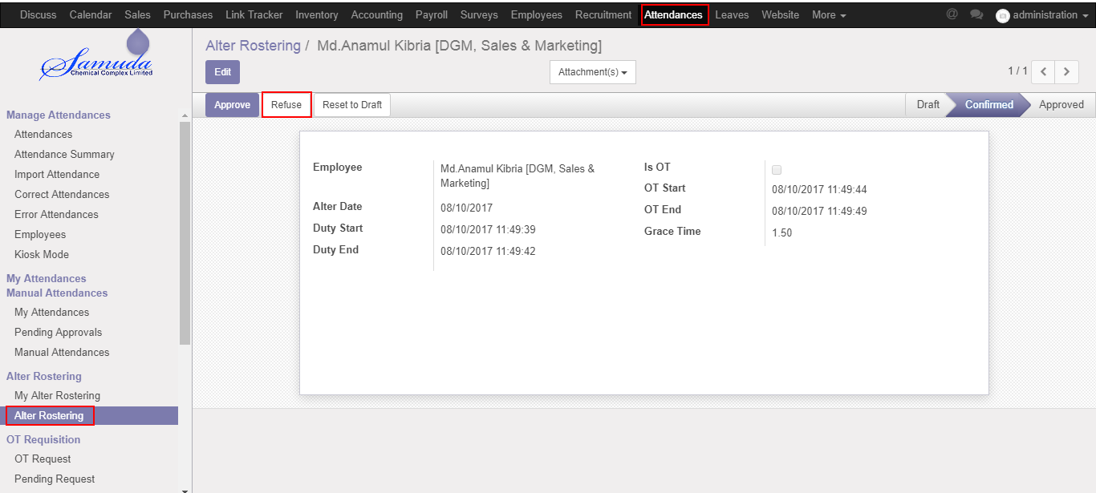

Figure: An Alter Rostering Request Refuse

# 9. OT Request Approval by Department Manager

## 9.1 Pending OT Request

Department manager can see all of employee pending OT request.

Using the menu **Attendance ‣ Pending Request**.

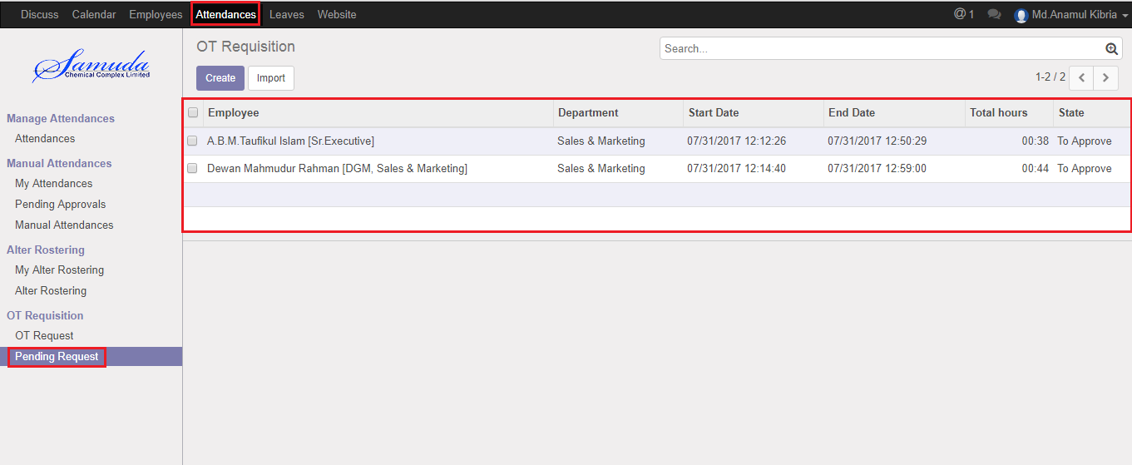

Figure: An OT Request Pending List View

## 9.2 Approval OT Request by Department manager

After apply the OT Request “Department Manager” will see all OT Request on **Pending Request** menu. Department Manager can first approve the OT Request.

To see the employee OT Request use the menu **Attendance ‣ Pending Request**. Here Department Manager can first approve the OT Request by click on **Approve** button.



Figure: OT Request Approval Form View

Department Manager can refuse OT Request by click **Refuse** Button.



Figure: A OT Request Refuse Form View

# 10. OT Request Approval by HR Manager

## 10.1 Pending OT Request

HR manager can see all of employee pending OT request. Using the menu **Attendance ‣ Pending Request**.

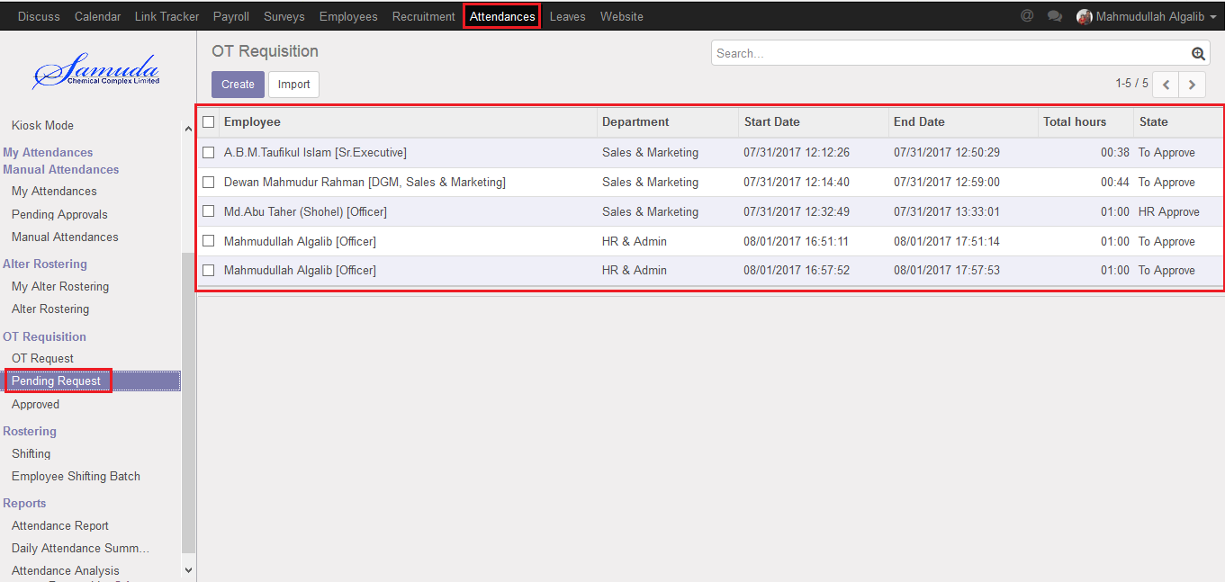

Figure: An OT Request Pending List View

## 10.2 Approval OT Request by HR manager

After approval by Department Manager the OT Request “HR Manager” will see all OT Request on **Pending Request** menu. HR Manager can final approve the OT Request.

To see the employee OT Request use the menu **Attendance ‣ Pending Request**. Here HR Manager can final approve the OT Request by click on **Approve** button.

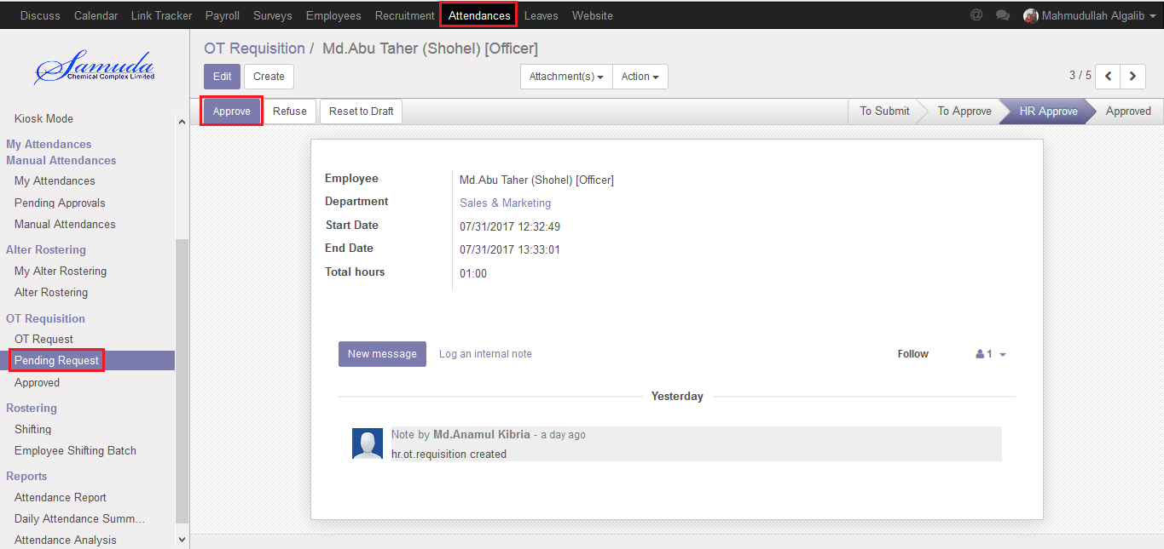

Figure: OT Request Approval Form View

HR Manager can refuse OT Request by click **Refuse** Button.

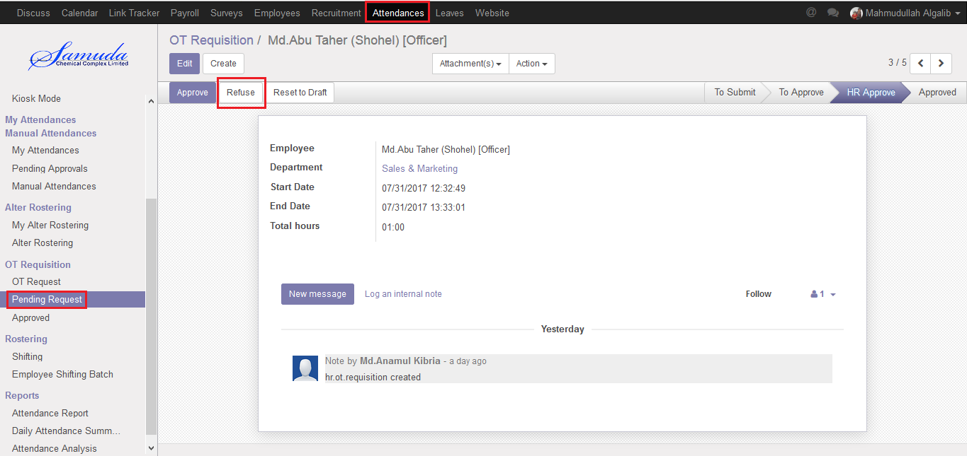

Figure: A OT Request Refuse Form View